Soroptimist International
Genève-Fondateur

We are an organisation of women working for women. The name Soroptimist, which comes from the Latin words ‘soror’ (sister) and ‘optima’ (the best), means ‘the best for women’ or ‘women for a better world’.
Our vast activities span many domains, addressing topics such as education, leadership, financial independence, eradicating violence against women, the environment, food security and health.

We offer our members a professional, social and international network. Soroptimist International is the world’s largest association of women’s service clubs, with 90,000 members representing 3,000 clubs in 130 countries worldwide.

What about the Genève-Fondateur club?

Our club was the first branch of Soroptimist in Switzerland, founded in 1930.

Our members are active, dynamic women who care about the defence of women’s rights and the world we leave for future generations.

We carry out local, national and international projects, all of which are financed by service activities.

.

What do we do?

By taking a stand on specific issues, we provide a universal voice for women.

By tapping into a global network of members, and thanks to our consultative status with the Economic and Social Council of the United Nations, we can help women and girls to make their voices heard by international political and decision-making bodies.

Our clubs and members help to improve women’s living conditions in very tangible ways.

In 2013 alone, our clubs carried out some 4,500 projects worldwide.

Soroptimist International
Genève-Fondateur

Soror optima
’Women for a better world’
Are you an active woman?
Join the club!
CONTACT
soroptimist.genevefondateur@gmail.com

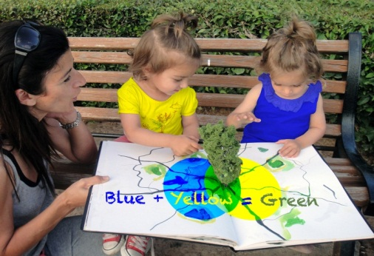

www.soroptimistgeneve-fondateur.ch
www.soroptimistinternational.org
www.soroptimisteurope.org
www.soroptimst.ch
Activities undertaken by the Genève-Fondateur club in recent years

Local

Financial support for a number of local organisations, including Camarada, Appartenances, Solidarité Femmes, Au Cœur des Grottes, Foyer Arabelle, Colis du Cœur, Télécontact, Foyer-Handicap, Carrefour-Rue, Le Caré, and more.

Organisation of fundraising concerts, sales and markets, and collaborations with the other service clubs in Geneva in support of various organisations.

Promoting education and financial independence for women: supporting the Microcrédit Solidaire Suisse, providing loans to women in Switzerland, and providing funding and grants to young women studying or in vocational training.

Promoting health and the environment: ‘Swimathlon’, fundraising for multiple sclerosis research and donating to the Pointe-à-la-Bise nature centre in Collonge-Bellerive, in support of the project ‘Water and natural resources in Switzerland’.

Cultural activities: annual ‘Coup de cœur des Sorop’ award for young female pianists and supporting the publication of Les femmes racontent (Women tell their stories), published by L’Encre fraîche.
Activities undertaken by the Genève-Fondateur club in recent years

International

Limbs for Life, in partnership with the International Committee of the Red Cross, helping victims of anti-personnel mines in Afghanistan, Georgia and Angola and the fundraising event ‘Les Clubs Soroptimist s’engagent pour l’eau’ to help the Geneva-based association H2O-Energies in its efforts to increase the availability of drinking water in Kenya.
Events

A wide range of talks by national and international experts helping us to better understand a variety of topical and pressing issues:
Monica Bonfanti, Geneva’s chief of police (developments the Geneva police’s handing of abused women); Martine Brunschwig-Graf, president of the Federal Commission against Racism; round table with experts on human trafficking, organised in cooperation with the Graduate Institute of International and Development Studies; Jacques Hainard, former director of the ethnography museums of Geneva and Neuchâtel; François Longchamp, member of the state council of Geneva; Philippe Roch, author of Dialogue avec Jean-Jacques Rousseau sur la nature; Nathalie Hardyn, assistant director of the Geneva chamber of commerce, industry and services; Myriam Nicolazzi, magistrate at the cantonal audit court; and Béatrice Cortellini, director of Solidarité Femmes.

